EXPT NO:5A | DATA VISUALIZATION USING MATPLOTLIB – SALES DATA

Aim:
To visualize dataset features and distributions using line charts, bar charts, pie charts, histograms, scatter plots, and box plots using Matplotlib.

Algorithm:
ALGORITHM 1: LINE CHART
Objective: To visualize the monthly sales trend.

Steps
- Load the sales dataset.
- Select the Month and Sales columns.
- Plot the monthly sales using a line chart.
- Add title and axis labels.
- Display the graph.

Interpretation
The line chart shows how sales vary across different months and helps identify the sales trend. # Program 1: Line Chart
plt.plot(months, sales) plt.title("Monthly Sales") plt.xlabel("Months") plt.ylabel("Sales") plt.show()
ALGORITHM 2: BAR CHART
Objective: To compare sales across different months.

Steps
- Select the Month and Sales columns.
- Create a bar chart using the monthly sales values.
- Add title and axis labels.
- Display the chart.

Interpretation
The bar chart helps compare the sales values across different months. # Program 2: Bar Chart
plt.bar(months, sales) plt.title("Monthly Sales") plt.xlabel("Months") plt.ylabel("Sales") plt.show()

ALGORITHM 3: PIE CHART
Objective: To visualize the distribution of sales across different months.

Steps
- Select the sales values.
- Create a pie chart using the sales values.
- Display percentage labels.
- Add a suitable title.
- Display the chart.

Interpretation
The pie chart shows the percentage contribution of each month to the total sales. # Program 3: Pie Chart
plt.pie(sales, labels=months, autopct="%1.1f%%") plt.title("Sales Distribution")
plt.show()

ALGORITHM 4: HISTOGRAM
Objective: To visualize the distribution of sales values.

Steps
- Select the Sales column.
- Divide the sales values into bins.
- Create a histogram.
- Add title and axis labels.
- Display the histogram.

Interpretation
The histogram shows the frequency distribution of the monthly sales values. # Program 4: Histogram
plt.hist(sales, bins=5) plt.title("Sales Distribution") plt.xlabel("Sales") plt.ylabel("Frequency") plt.show()

ALGORITHM 5: SCATTER PLOT
Objective: To visualize the sales values for different months.

Steps
- Select Month as the X-axis variable.
- Select Sales as the Y-axis variable.
- Create a scatter plot.
- Add title and axis labels.
- Display the graph.

Interpretation
The scatter plot shows the variation in sales across different months. # Program 5: Scatter Plot
plt.scatter(months, sales) plt.title("Monthly Sales") plt.xlabel("Months") plt.ylabel("Sales")
plt.show()

ALGORITHM 6: BOX PLOT
Objective: To visualize the distribution of monthly sales.

Steps
- Select the Sales column.
- Create a box plot.
- Add a suitable title and axis label.
- Display the plot.

Interpretation
The box plot shows the distribution of sales values and helps identify possible outliers. # Program 6: Box Plot
plt.boxplot(sales) plt.title("Sales Box Plot") plt.ylabel("Sales") plt.show()

ALGORITHM 7: MULTIPLE LINE CHARTS
Objective: To compare sales and profit across different months.

Steps
- Store the profit values.
- Plot the sales values using a line chart.
- Plot the profit values using another line chart.
- Add title, axis labels and legend.
- Display the graph.

Interpretation
The multiple line chart compares the sales and profit values across different months. # Program 7: Multiple Line Charts
profit = [20, 30, 40, 35, 50, 60]

plt.plot(months, sales, label="Sales") plt.plot(months, profit, label="Profit")
plt.title("Sales and Profit") plt.xlabel("Months") plt.ylabel("Value") plt.legend()
plt.show()

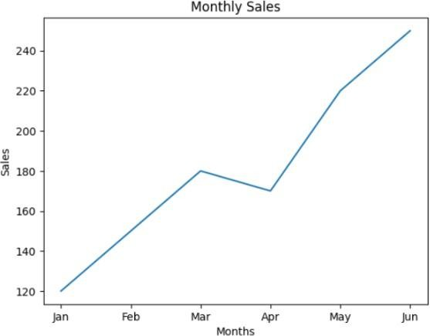
Output:

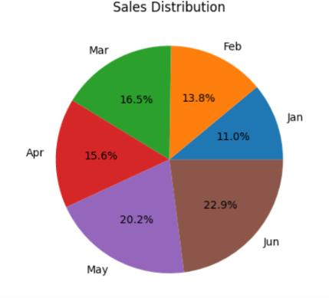
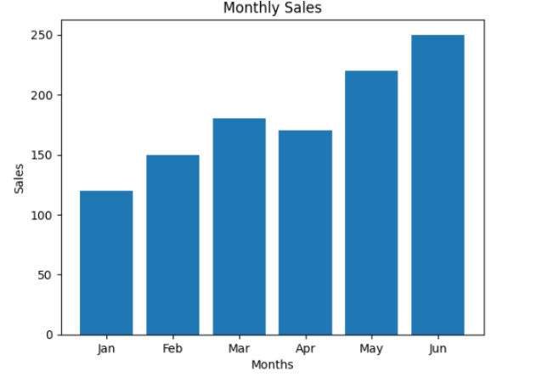

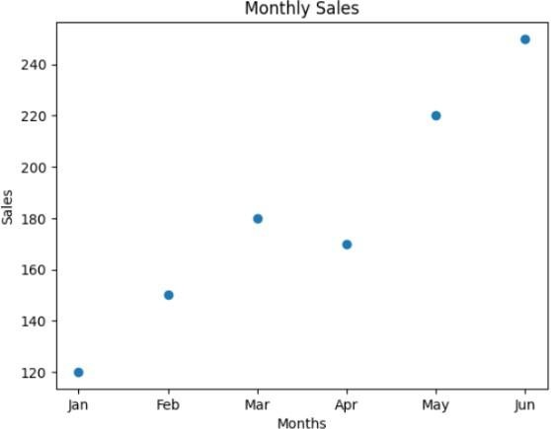
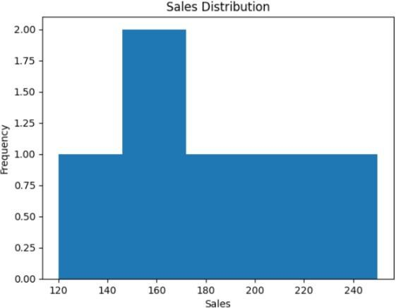

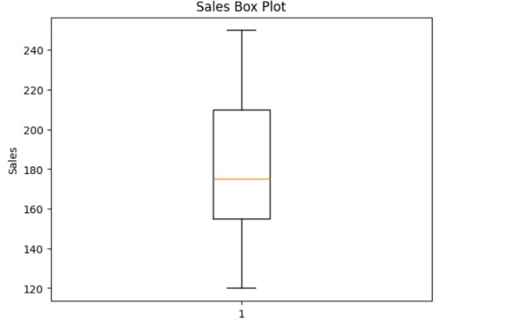
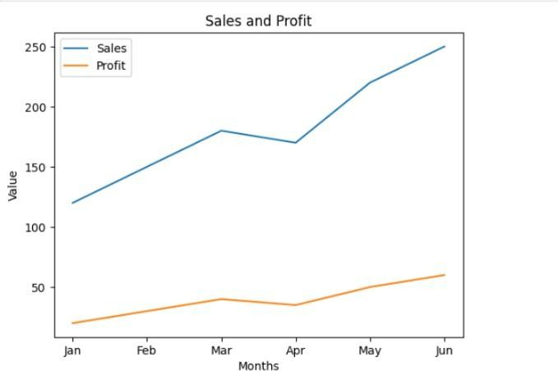

Result:

